ASR 3B2 mapping changes:

Shipped on This Date – change from Orders.Deliverydate to Current date.

**Sent:** Tuesday, February 27, 2018 3:19 PM  
**To:** Wang, Lirui (GIS) <[Lirui.Wang@sony.com](mailto:Lirui.Wang@sony.com)>; Chan, Pei-Fong <[pei-fong.chan@dbschenker.com](mailto:pei-fong.chan@dbschenker.com)>; Zhou, Jenny <[Jenny.Zhou@sony.com](mailto:Jenny.Zhou@sony.com)>  
**Cc:** Zhang, Patrick <[Patrick.Zhang@sony.com](mailto:Patrick.Zhang@sony.com)>; Chen, Brian <[Brian.Chen@sony.com](mailto:Brian.Chen@sony.com)>; Matsubara, Jun (Sony Mobile) <[Jun.Matsubara@sony.com](mailto:Jun.Matsubara@sony.com)>; Miyamoto, Hiromi (Sony Mobile) <[hiromi.a.miyamoto@sony.com](mailto:hiromi.a.miyamoto@sony.com)>; Phoen, Eugene <[eugene-yj.phoen@dbschenker.com](mailto:eugene-yj.phoen@dbschenker.com)>; Low, Dennis <[dennis.low@dbschenker.com](mailto:dennis.low@dbschenker.com)>; DL-WW-SCHPJ-PMO <[DL-WW-SCHPJ-PMO@sonymobile.com](mailto:DL-WW-SCHPJ-PMO@sonymobile.com)>; SAP AM SD <[SAPAMSD@sonymobile.com](mailto:SAPAMSD@sonymobile.com)>; Tran, Gia-My <[Gia-My.Tran@dbschenker.com](mailto:Gia-My.Tran@dbschenker.com)>; Lee, Kar Mun <[kar-mun.lee@dbschenker.com](mailto:kar-mun.lee@dbschenker.com)>; Takashima, Kazuyo X (Sony Mobile) <[Kazuyo.X.Takashima@sony.com](mailto:Kazuyo.X.Takashima@sony.com)>; ITPC.ICAM <[ITPC.ICAM@sonymobile.com](mailto:ITPC.ICAM@sonymobile.com)>; Radhakrishnan, HariKumar (EXT) <[HariKumar.Radhakrishnan@sonymobile.com](mailto:HariKumar.Radhakrishnan@sonymobile.com)>; Wang, Shuo 3 (GIS) <[Shuo.1.Wang@sony.com](mailto:Shuo.1.Wang@sony.com)>  
**Subject:** RE: 2969004-RE: Actual shipment dates are not correct

Hi Lirui and Pei_Fong,

As per the mapping in IC, the mentioned value should be "Shipped on This Date", refers as below:

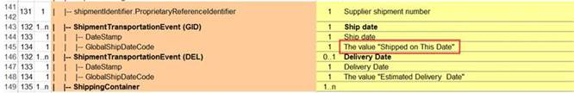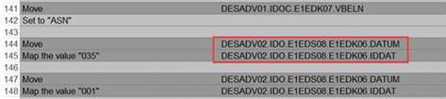

Updated:

2018.02.28

